Report on Public Footpaths in the Parish
Footpath CHV/8/1 crossing Susan Mackenzie’s and the late Jill Phillips land
Stile has fallen over (both supporting posts have rotted where they meet the ground). (probably stile CHV/50). Stile sits on boundary between land owned by the late Jill Phillips, and by Sue Mackenzie.
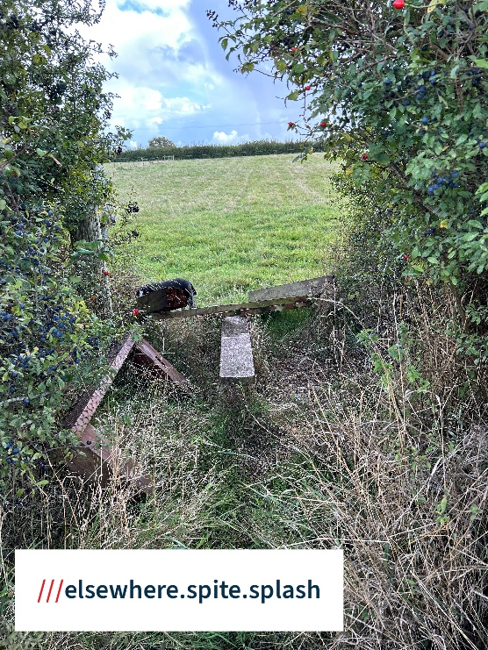
CHV/16/1
There is now no stile near the start of footpath CHV/16/1. So as make clear where the foopath starts, it would be helpful if there was a finger post at the junction with the track CHV/12/1
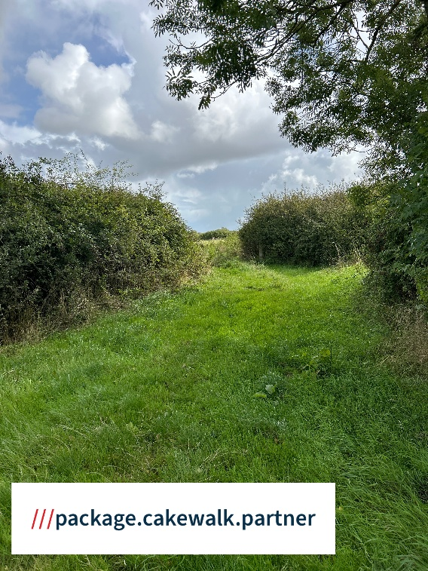

Footpath CHV/28/1 running south east from the Yew Tree
Stile CHV/179- Both of the stile’s supporting posts are rotted through at ground level. Stile is unstable and part held vertical by the wire stock proof fencing.
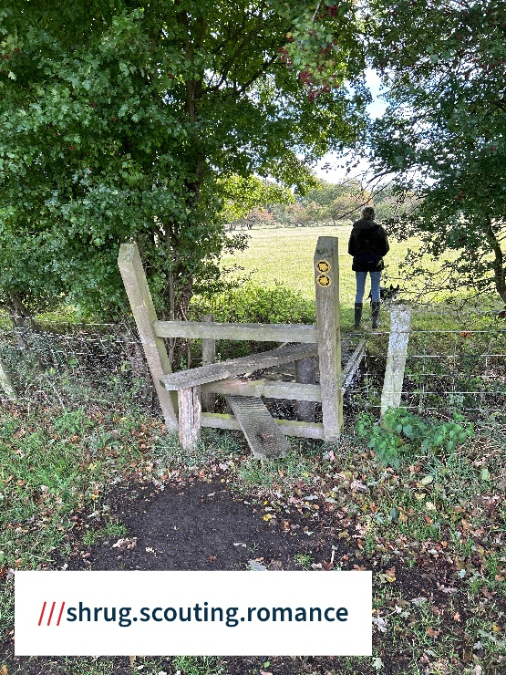
Footpath CHV/21/1 connecting Mill Lane to Darp Lane
The finger post CHV/131 (ref W08810) showing start of the footpath CNV/21/1 from Mill Lane has been removed.
Curls Farm Land
Fingerpost
At western end of lake, the finger post CHV24(ref W06810), it is dilapidated, and needs replacing.
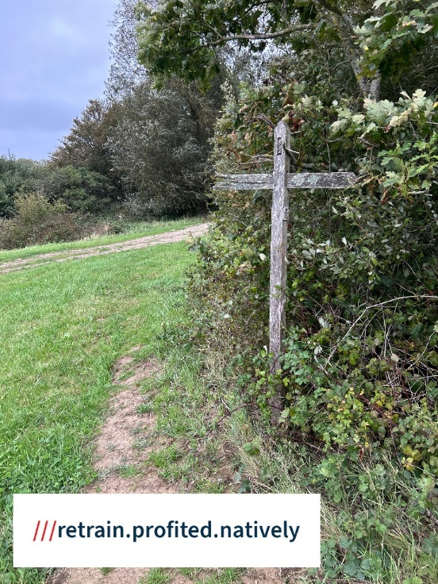

Overgrown path CHV/4/1
This footpath runs to the west of Curls Farm Lake
Finger post CHV/22 (ref W1165), and waymark post CHV20(ref W06811) on footpath CHV/4/1 are both missing, and need replacing.
Where you enter the wood the route of the path is overgrown is lost
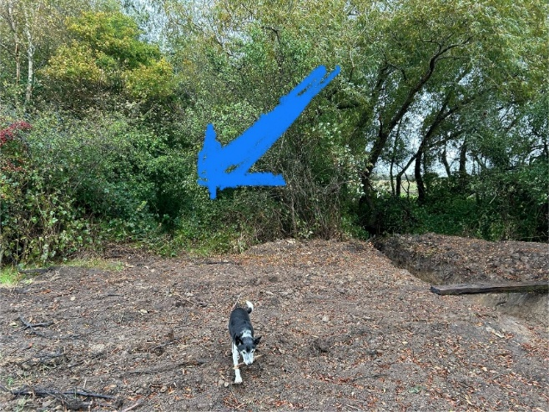
(Location of photo above is ///reclined.spoils.masking) The path would lead to a bridge CHV/19 over a stream, the bridge is very overgrown with brambles

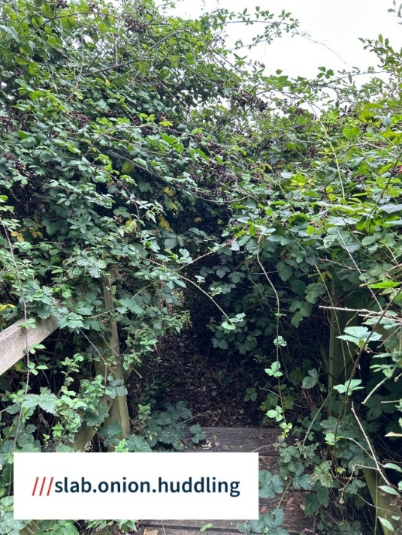
The route of the path leading across fields to come out at Little Stream Farm, Mill Lane is not defined.

